**Oliver Hall FYP *Friends* Sentiment Analysis Questionnaire**

Thank you for agreeing to be part of this research study. If you have not watched all 10 seasons of *Friends*, please inform the researcher now.

The following questionnaire will ask you to plot, on a graph, your perceptions of the six main characters at various points throughout the show. The questionnaire is only focused on positive vs negative sentiment. A perception of positive sentiment would be if you perceived an entity as “good”, “safe”, “happy” etc. Negative sentiment would classify as something “bad”, “unfriendly” or “dangerous”. Major plot points for each character have been added to the graphs for reference.

The questionnaire is divided into three sections. Section A is mandatory, whereas Section B and C are both optional and require additional rewatching. Please outline to the researcher **now** which sections you are happy to fill out.

* Section A refers to the entire series of *Friends*. There is no required rewatching for this section, but you must have seen the show in its entirety before.
* Section B refers to the 10th Season of *Friends*. If you wish to fill in this section of the questionnaire, please rewatch the 10th Season of *Friends* before Friday 7th May, and fill in this section while doing so. Please note that you can fill out this section whilst watching. (This section is optional)
* Section C refers to the last two episodes of *Friends* (episodes 17 and 18 of season 10, sometimes referred to as a single episode). If you wish to complete this section, please rewatch the final two episodes of *Friends* before Friday 14th May, and fill in this section while doing so. Please note that you can fill out this section whilst watching. (This section is optional)

Please be aware that all personal data will be kept anonymous, with each participant being referred to with a given letter, i.e “Participant 24’s graph for Ross looked like…”.

If you have any questions relating to the instructions provided above, please inform the researcher.

Please sign and date below (printing your name is fine) to state that you have read and fully understood the above instructions.

Signed: Date:



**SECTION A – Entire Series (Mandatory)**

*Question 1) Please plot your feelings towards* ***Chandler*** *throughout all 10 seasons. A quick recap of his main plot points for each season is given below. The graph is on the following page.*

Season 1 – Chandler is introduced as sarcastic and afraid of commitment. He has an on-off relationship with Janice and relapses into smoking again. He reassures Ross that he will be a good father and tells him to stop pursuing Rachel. At the end of the season he lets slip to Rachel that Ross is in love with her.

Season 2 – Chandler persuades Ross to make a pros and cons list of Rachel and Julie. Chandler loses Ben on a bus. He meets a woman online before deciding to meet up in person – it is Janice.

Season 3 – Chandler finds out that Janice is cheating on him with her ex husband. He decides to let her go so that she can have a family, lamenting his own lack of a stable upbringing. Chandler kisses Joey’s sister. Chandler tells Ross to cover up any evidence that he slept with Chloe while on a break from Rachel. Chandler goes back to smoking but is helped to quit by Rachel.

Season 4 – Chandler pees on Monica to soothe a jellyfish sting. Chandler is attracted to Joey’s girlfriend Cathy and tries to avoid her. The two share a kiss. He feels guilty and tells Joey. Chandler stays in a box for six hours to make it up to Joey. Cathy arrives to say goodbye to Chandler in the box – Chandler stays silent, loyal to Joey. Cathy is sleeping with a co-star, leaving Joey devastated. Chandler and Monica sleep together in London.

Season 5 – Chandler and Monica begin to date in secret. He accidentally blurts out “I love you” at Thanksgiving, after it transpires that Monica accidentally cut off his toe as payback for him calling her fat. Chandler pretends to seduce Phoebe to keep his relationship with Monica a secret. He starts to accept the commitment that he has made with Monica, instead of fleeing from it. Chandler admits that he doesn’t believe Joey’s movie is his big break. Chandler and Monica go to Vegas, where they make plans to get married.

Season 6 – Chandler and Monica move in together. He plans to propose to her, but is flustered when Richard shows up. To throw Monica off, Chandler pretends to be disgusted at the concept of marriage. Monica finds out and he proposes at the end of the season.

Season 7 – Chandler becomes upset when he learns Monica originally wanted to sleep with Joey. Chandler freaks out about not being a good enough husband to Monica and runs away to his office. Helped by Ross, he makes it to the wedding.

Season 8 – Chandler let’s Ross win an arm-wrestling match to impress a girl. He supports Rachel through her pregnancy. He consoles Joey when he’s having feelings for Rachel. He feels he is ready to have children with Monica after Rachel gives birth during the season finale.

Season 9 – Chandler accidentally agrees to move to Tulsa for his job. He soon realises the strain this is putting on his marriage and consequentially quits his job to be closer to Monica and do something he cares about. He becomes devastated when he realises that he and Monica cannot conceive. They decide to pursue adoption.

Season 10 – Chandler shows integrity and truthfulness towards Erica (whose children they are going to adopt), and wins her trust by giving a heart-warming speech. When Erica gives birth to twins, he freaks out and doubts their capability, but soon becomes overjoyed. He and Monica move to the suburbs, promising to visit Joey.

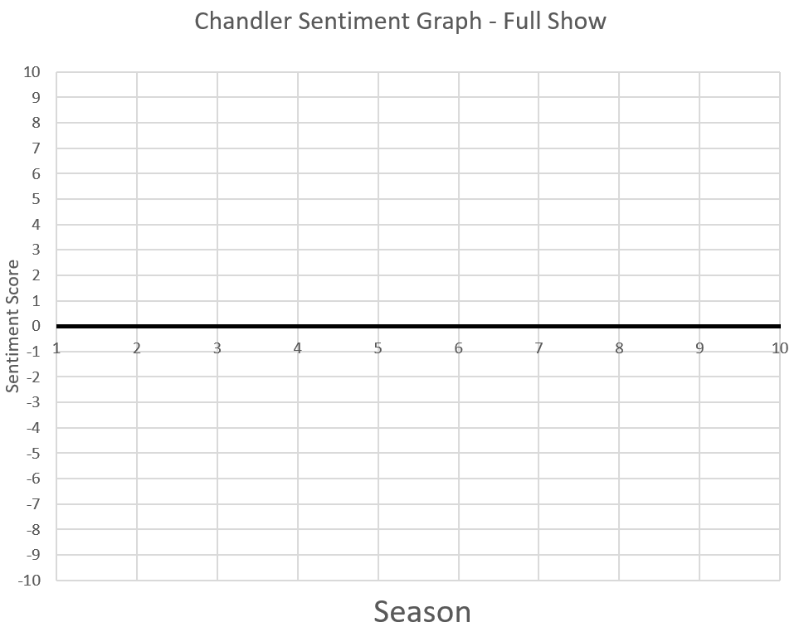



*Question 2) Please plot your feelings towards* ***Monica*** *throughout all 10 seasons. A quick recap of her main plot points for each season is given below. The graph is on the following page.*

Season 1 – Monica helps Rachel become independent. She also hosts Thanksgiving for the friends, trying to accommodate for everyone.

Season 2 – Monica loses her job and falls in love with Richard. She takes a job at Moondance Diner before Richard admits that he doesn’t want children. Monica breaks up with him and describes getting over him as one of the hardest things she ever had to do.

Season 3 – Monica meets Pete, who is rich but she doesn’t feel attracted to him. Pete offers her a job at a restaurant and turns it down. She calls off the relationship when Pete wants to become a cage fighter. Chandler offers to be her boyfriend, to which she replies “you’re not boyfriend material, you’re Chandler”.

Season 4 – Monica starts to date Richard’s son, but breaks up with him as she finds it too weird. Monica struggles to be respected by her staff at a new job. Monica bets the apartment in a game against Joey and Chandler. Monica becomes depressed as her mother chips away at her ego. Monica sleeps with Chandler in London.

Season 5 – Monica and Chandler begin a relationship. The gang find out as Monica encourages Chandler to pretend to have romantic feelings for Phoebe. Chandler and Monica go to Vegas, where they make plans to get married.

Season 6 – Chandler and Monica move in together. Richard arrives at the restaurant where Monica works and declares his love for her, saying that he wants to marry her. She denies his proposal, before agreeing to marry Chandler.

Season 7 – Monica tries to convince Chandler to use his savings to pay for her dream wedding. Monica realises she wants the same thing as Chandler: a marriage.

Season 8 – Monica unwraps the wedding presents without Chandler. Monica and Chandler decide they want to have a child and have sex in a janitor’s closet while Rachel is in labour.

Season 9 – Monica almost goes with Chandler to Tulsa but instead accepts her dream job in New York. Monica rules out surrogacy as she wants to have her own child and rejects sperm donation as she wants to have Chandler’s child. In the end, they decide to adopt.

Season 10 – Monica and Chandler adopt both of Erica’s children. In the last episode, Monica helps Ross to realise that he should go after Rachel.

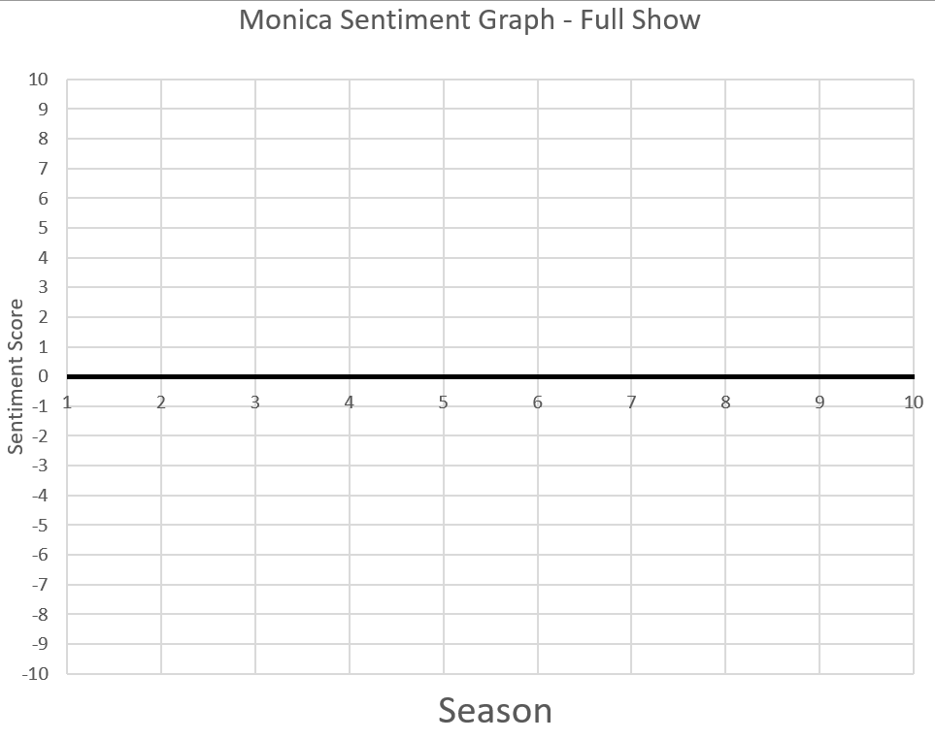



*Question 3) Please plot your feelings towards* ***Joey*** *throughout all 10 seasons. A quick recap of his main plot points for each season is given below. The graph is on the following page.*

Season 1 – Joey tries to convince Ross to sleep with lots of women. Joey pretends that Monica is his girlfriend to win over Angela, without telling Monica. Joey finds out that his father is cheating on his mother, and forces his father to own up to it. Joey starts to date Phoebe’s twin sister, hurting Phoebe’s feelings. Joey helps a woman through her labour, but when he returns with balloons he discovers that the father of the baby has arrived.

Season 2 – Wanting to be independent, Joey moves into his own apartment. After being killed off Days of Our Lives, and missing his best friend, Joey moves back into his apartment with Chandler.

Season 3 – Joey starts to teach acting classes, but sabotages one of his students preparing for the same role as him.

Season 4 – When Monica is bullied by restaurant staff, Joey decides to help her out by letting her fire him.

Season 5 – Joey embarrasses himself so that Chandler and Monica can keep their relationship a secret. Joey desperately tries to hide the failure of his movie from the friends, as he’s worried they will think of him as a failure.

Season 6 – Joey desperately hunts for work, including becoming a waiter at Central Perk.

Season 7 – Joey really wants to conduct the wedding of Monica and Chandler, and goes to great lengths to ensure that he does a good job for them both.

Season 8 – Joey goes on a date with Rachel to prepare for another date, but he starts to develop feelings for Rachel. He eventually tells her and is heartbroken when she doesn’t reciprocate. Rachel accepts what she believes is a proposal from Joey but was actually a ring that belonged to Ross.

Season 9 – Joey and Phoebe set up Ross and Rachel on disastrous dates. He also dates Charlie, Ross’ co-worker. This relationship ends when he and Rachel find out they are both attracted to each other.

Season 10 – Joey and Rachel decide that they are too good as friends to risk a relationship. He conducts the wedding of Phoebe and Mike, and although he is worried about being left alone once Monica and Chandler leave, he feels confident in himself moving forward.

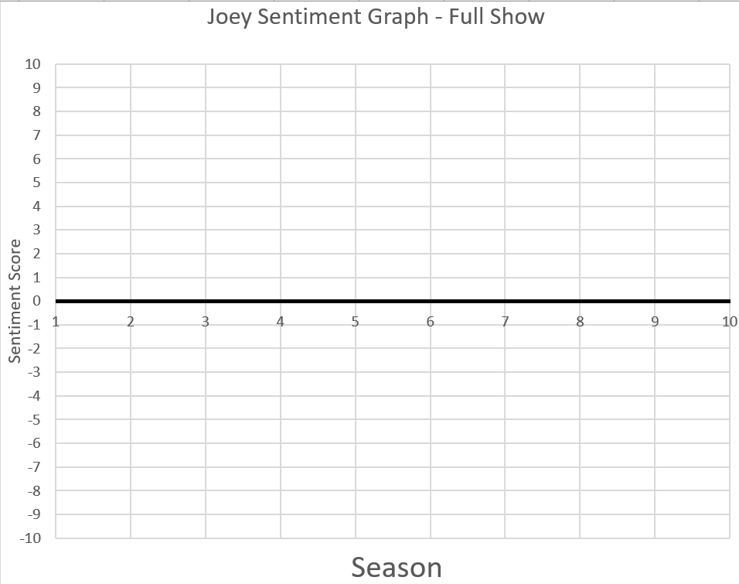



*Question 4) Please plot your feelings towards* ***Rachel*** *throughout all 10 seasons. A quick recap of her main plot points for each season is given below. The graph is on the following page.*

Season 1 – Rachel confronts her father over the phone about her fleeing from her wedding to Barry and announces that she’s moving in with Monica. She stands up to a bully at the laundromat, proud of her new achievements as an independent person. Rachel starts to date Paolo, even though he speaks no English. She finds out that Ross loves her. She goes to the airport after realising she has feelings for him too.

Season 2 – Rachel tries to sabotage Ross and Julie’s relationship. Rachel leaves Ross a drunk voice message saying that she’s over him, leading them to share a kiss. She starts to date Russ (a man who looks a lot like Ross). She finds out that Ross tried to confess his feelings at her prom, so she kisses him. They sleep together in the museum. Rachel is the butt of jokes at Barry and Mindy’s wedding, but stays through the wedding in defiance.

Season 3 – Rachel gets close with Mark at Bloomingdales. After an argument, Ross sleeps with Chloe. Unaware of this, Rachel apologises to Ross for how she acted. Rachel finds out about Chloe, and her and Ross have a rough break up. Rachel sabotages Ross’ future relationships before kissing him in the season finale.

Season 4 – Rachel writes an 18-page letter to Ross. It transpires that he accepts no responsibility for their break-up, leading Rachel to humiliate and provoke him. Rachel lusts after Joshua, embarrassing herself in the process. Rachel goes to London to tell Ross that she is still in love with him at his wedding.

Season 5 – Rachel agrees to go on Ross’ honeymoon with him as a friend, but he never gets on the flight. She gets a job at Ralph Lauren, where she smokes with her colleagues to try to fit in. Her and Ross drunkenly get married in Vegas.

Season 6 – Rachel is hurt but ultimately happy for Chandler and Monica when they decide to live together. She starts a relationship with Ross’ partner Elizabeth’s father.

Season 7 – Rachel is promoted and starts to date her personal assistant, Tag. She blames Tag for a mistake of hers and breaks up with him on her 30th birthday. Her and Ross sleep together another time and it transpires that Rachel is pregnant.

Season 8 – Whilst giving birth, Joey accidentally proposes to Rachel and she says yes, unaware that it was Ross who planned to propose to her.

Season 9 – Rachel becomes increasingly interested in Joey, and the two share a kiss in the season finale.

Season 10 – Rachel and Joey decide to stay friends, and Rachel focuses increasingly on her daughter. Rachel tells Monica that she believes Chandler is having an affair. Rachel is offered a new job in Paris and although Ross begs her to stay, she gets on the plane. She leaves a message for Ross saying that she’s trying to get off the plane. She arrives at Ross’ door and the two share a kiss.

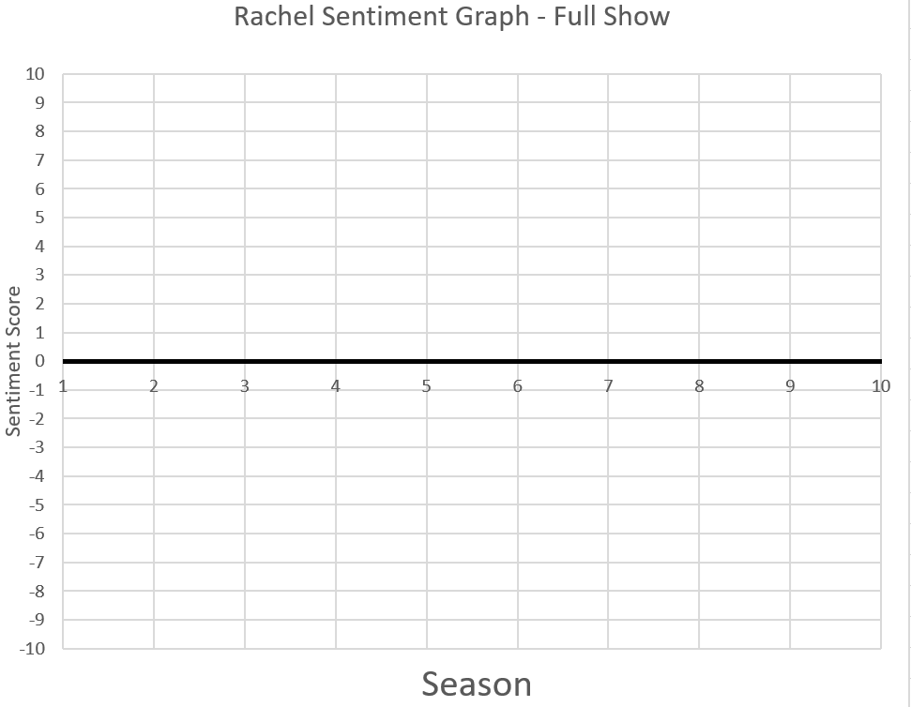



*Question 5) Please plot your feelings towards* ***Phoebe*** *throughout all 10 seasons. A quick recap of his main plot points for each season is given below. The graph is on the following page.*

Season 1 – Phoebe is revealed as the odd, kind and charitable one of the group. When she finds a thumb in a soda, she tries to give away the $7000 compensation.

Season 2 – Phoebe starts to search for her father and finds out that she has a younger half-brother, who she bonds with after he reveals their father abandoned him too.

Season 3 – Phoebe finds out about a friend of her adoptive mother’s, Phoebe Abbott, who lives on the beach. They take a trip to the beach, where Phoebe finds out that Phoebe Abbott is actually her birth mother.

Season 4 – Phoebe agrees to be a surrogate mother for her half-brother, though she is unable to attend Ross’ wedding in London and feels left out.

Season 5 – Phoebe gives birth to triplets and though she is hesitant to give away the babies, she eventually accepts that it is the right thing to do. She starts to date a cop, but breaks up with him when he shoots a bird.

Season 6 – Phoebe discovers Chandler’s secret plan to propose to Monica and helps him pick out the ring.

Season 7 – To protect Rachel, Phoebe claims that she is pregnant. Joey proposes to Phoebe so she wouldn’t have to raise a child alone.

Season 8 – Phoebe begins to date Eric, her twin sister’s ex-fiance. He cheats on Phoebe with her twin sister, thinking that it is her. While Rachel is in labour, Phoebe meets a cute man with a broken leg and attempts to find out information about him, who is very angry when he finds this out.

Season 9 – Phoebe finds herself stuck between Mike and David. She agrees to marry David, even though she is still in love with Mike. Mike bursts into the room as David proposes, and proposes first. Phoebe declines both, but agrees to continue her relationship with Mike. David leaves, sad that he has lost Phoebe and wasted years of his life on pointless research. She also conspires with Joey to set up Ross and Rachel on bad dates.

Season 10 – Phoebe and Mike finally get engaged. They decide to donate the money for their wedding to a charity for the children of New York, but Phoebe decides she wants the money back and have a large wedding. Phoebe fires Monica as wedding planner for being too overbearing. Phoebe tells Mike that she wants a simple ceremony, and the two get married outside Central Perk. In the final episode, Phoebe drives Ross to the airport to catch Rachel.



**Phoebe Sentiment Graph – Full Show**



*Question 6) Please plot your feelings towards* ***Ross*** *throughout all 10 seasons. A quick recap of his main plot points for each season is given below. The graph is on the following page.*

Season 1 – Ross falls in love with Rachel but becomes deeply jealous of her relationship with Paolo. He also kisses Chandler’s mum, upsetting Chandler. Ross allows Rachel to win a game of poker. Ross argues incessantly with his ex-wife Carol’s partner Susan.

Season 2 – Ross learns that Rachel has fallen for him, kissing her whilst still with his girlfriend Julie. He then makes a pros and cons list of Rachel and Julie. A videotape reveals that Ross tried to save the day on Rachel’s prom night when her date didn’t show up, but it was too late. Rachel forgives Ross for the list and the two enter a romantic relationship.

Season 3 – Ross becomes paranoid and suspects Rachel of having an affair. He constantly complains about how much time she is spending away from him and with Mark, a co-worker. Ross visits Rachel at her office, even though she tells him not to visit her while she is working. Ross sleeps with Chloe, justifying his actions by claiming that he and Rachel were on a break. He and Rachel are on and off for the rest of the season.

Season 4 – Rachel writes an 18 page letter to Ross, outlining how she felt betrayed by him and she wants him to take full responsibility for everything that went wrong in their relationship. Ross falls asleep while reading the letter and agrees to it without having read it. They have sex before Ross blurts out that he does not accept responsibility. The two start power games against each other. Ross quickly proposes to Emily, but at the altar he says Rachel’s name instead of Emily’s.

Season 5 – Ross fails to earn Emily’s forgiveness. Ross agrees to go on the honeymoon with Rachel. Emily agrees to trust him provided he never talks to Rachel again – a condition he agrees to before realising he cannot end his friendship with Rachel. After his second divorce, his anger gets him fired from the museum. Emily gets remarried, causing Ross to hate Emily and British culture.

Season 6 – Ross and Rachel get married in Vegas. He lies to Rachel, stating that he got the marriage annulled. Rachel is furious and hurt when she finds out. The two finally get a divorce.

Season 7 – Ross buys Phoebe a bike and teaches her how to ride it. Ross’ father gives Monica a Porsche, causing him to become jealous and self-centred. He purchases his own sports car.

Season 8 – Rachel becomes pregnant with Ross’ baby, but does not tell his current girlfriend. He also gives Mona a key to his apartment, but decides to have Rachel move in with him. Ross becomes furious with Joey when he accidentally proposes to Rachel.

Season 9 – Ross argues with Rachel after she kisses a colleague, even though the pair are not together romantically. He becomes jealous when a woman he has a crush on starts to date Joey. Joey later sees Ross and Charlie kissing, causing him to feel hurt and betrayed.

Season 10 – Ross tries to bribe Rachel’s boss into rehiring her at Ralph Lauren, so that she will not move to Paris. He becomes angry at Rachel when she does not give him a proper heartfelt goodbye. He goes to the airport to tell Rachel how much he loves her.

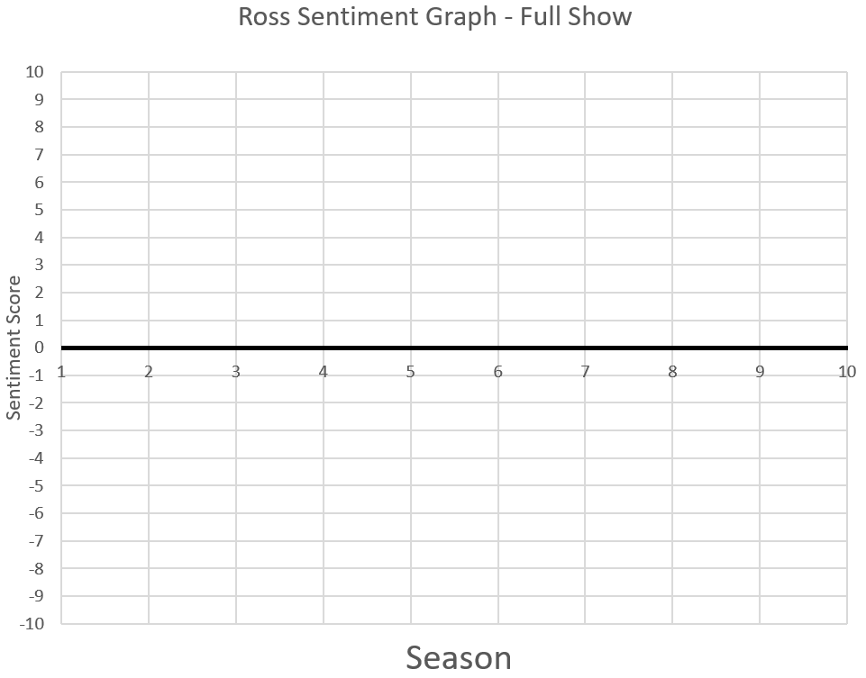



**SECTION B – Season 10 (Optional)**

Question 7) Please plot your feelings towards **Chandler** throughout Season 10.

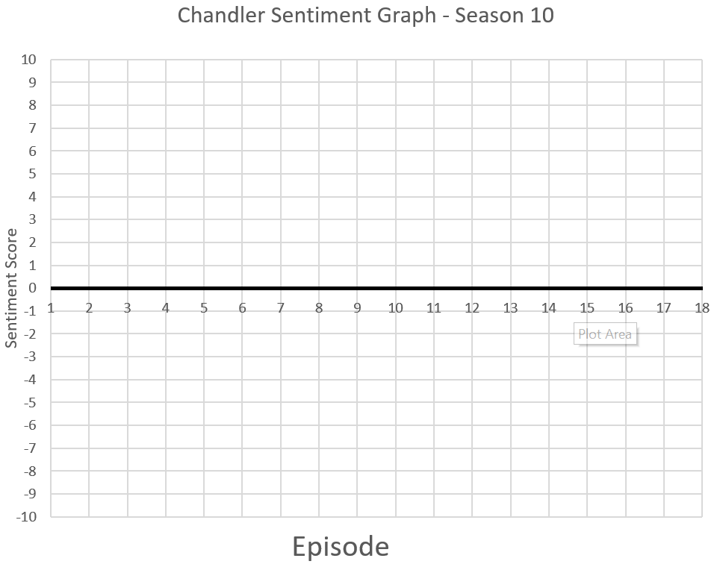

Question 8) Please plot your feelings towards **Monica** throughout Season 10.

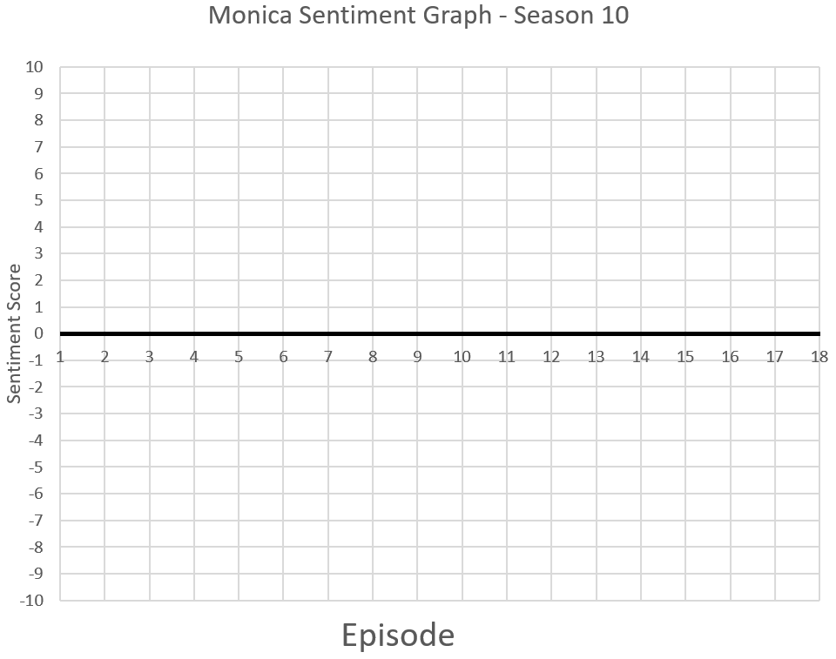

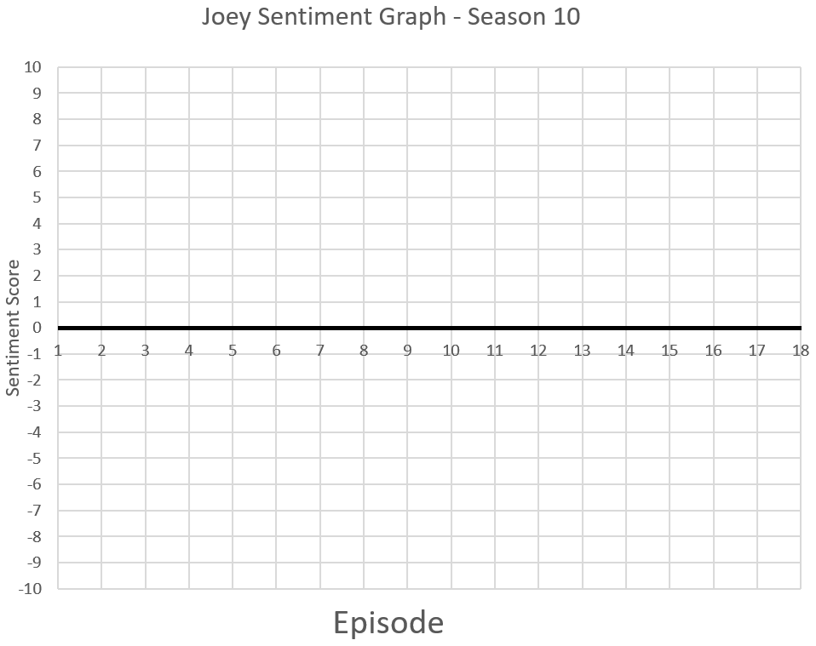Question 9) Please plot your feelings towards **Joey** throughout Season 10.

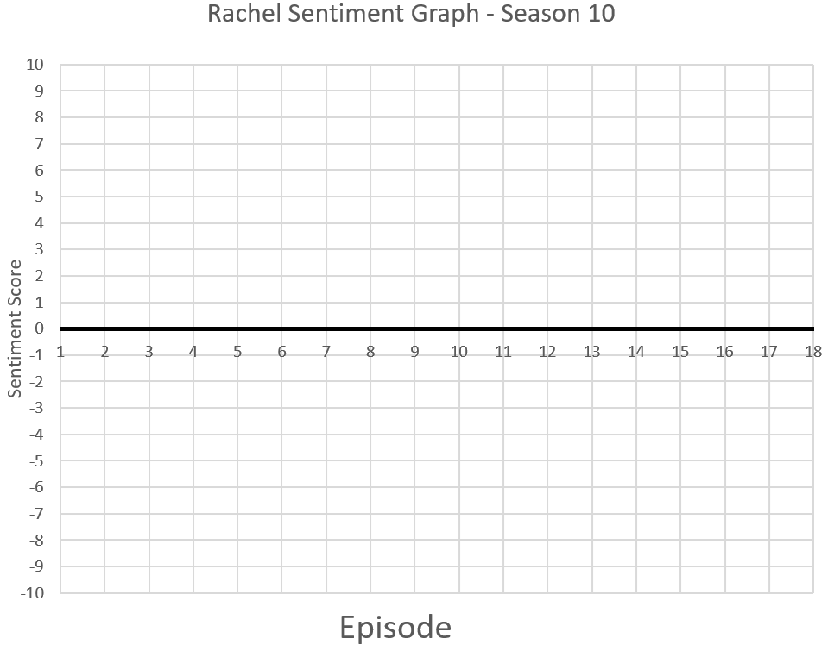Question 10) Please plot your feelings towards **Rachel** throughout Season 10.

Question 11) Please plot your feelings towards **Phoebe** throughout Season 10.

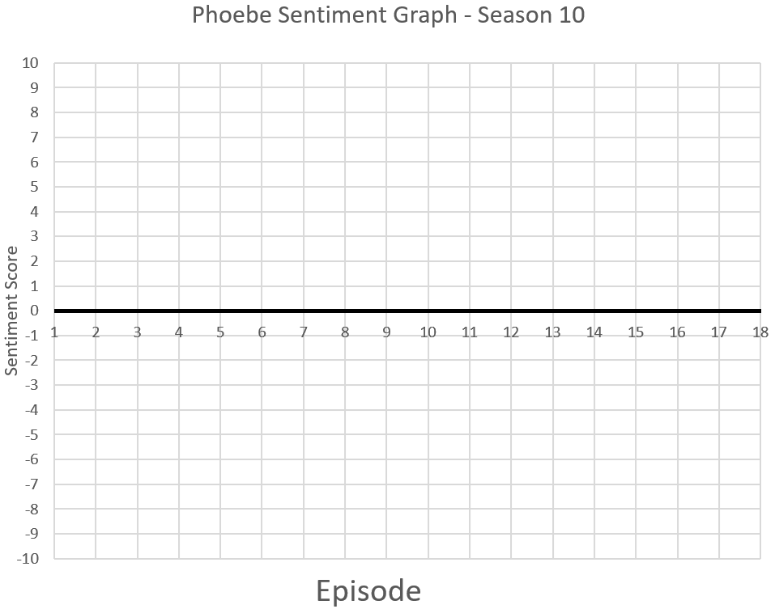

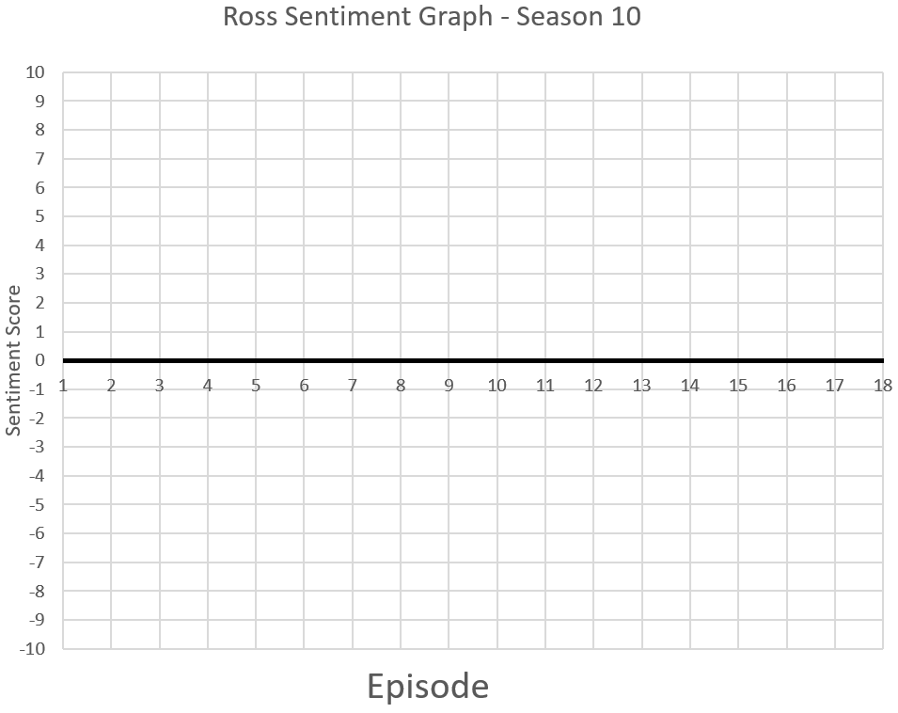Question 12) Please plot your feelings towards **Ross** throughout all Season 10.

**SECTION C – Season 10, Episodes 23+24 (Optional)**

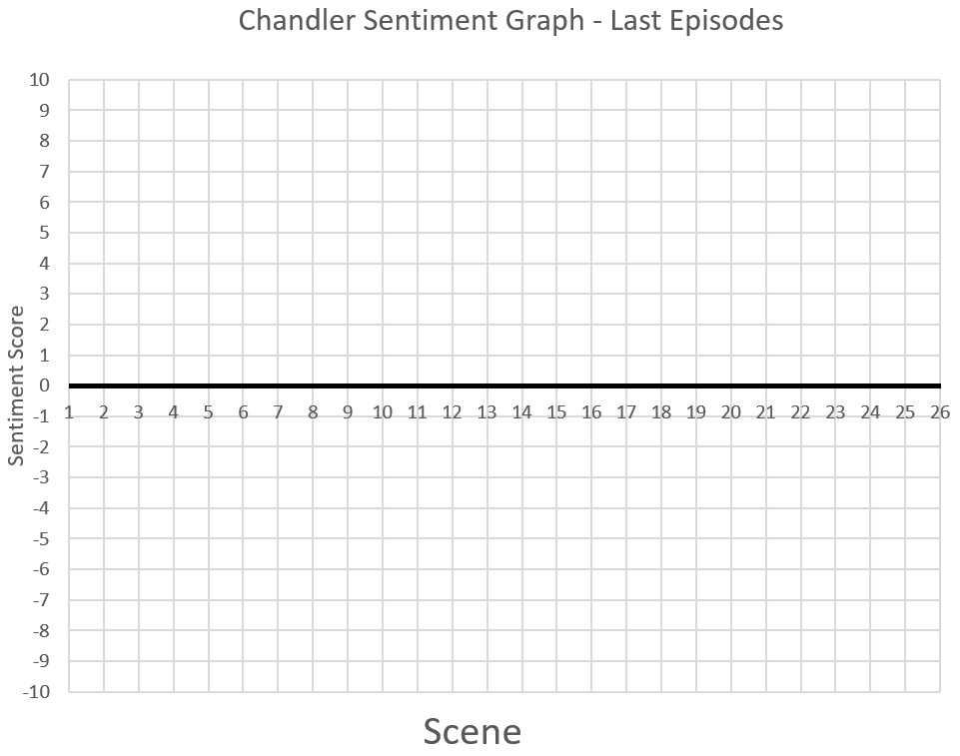Question 13) Please plot your feelings towards **Chandler** throughout the final two episodes.



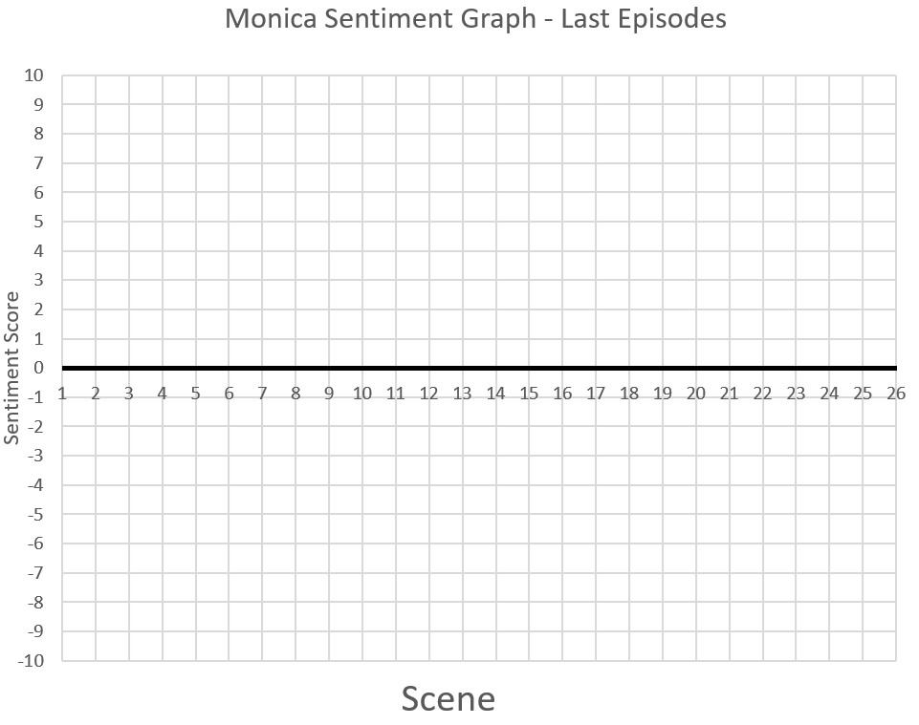Question 14) Please plot your feelings towards **Monica** throughout the final two episodes.



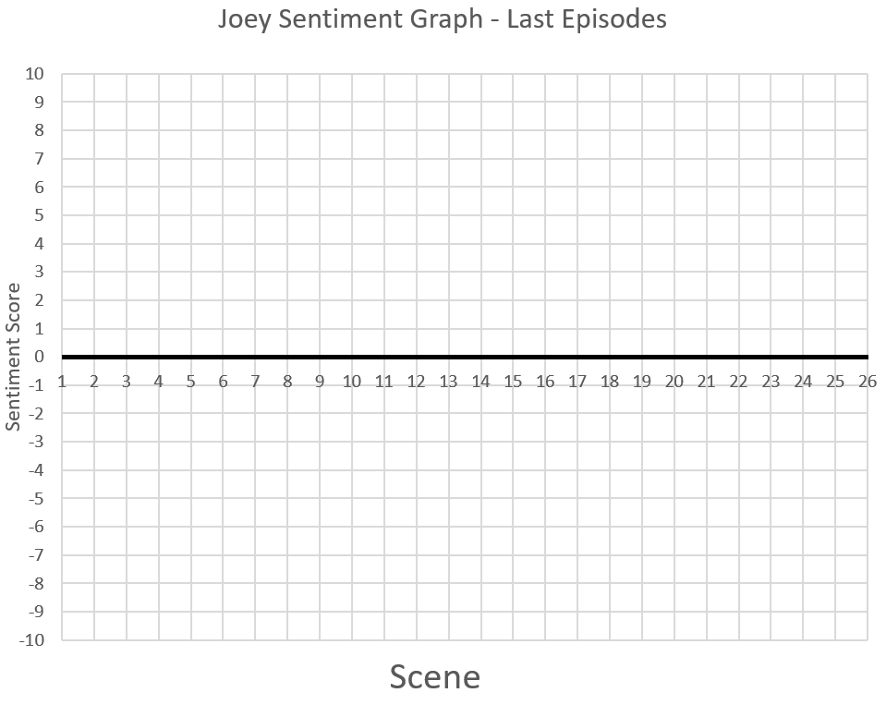Question 15) Please plot your feelings towards **Joey** throughout the final two episodes.



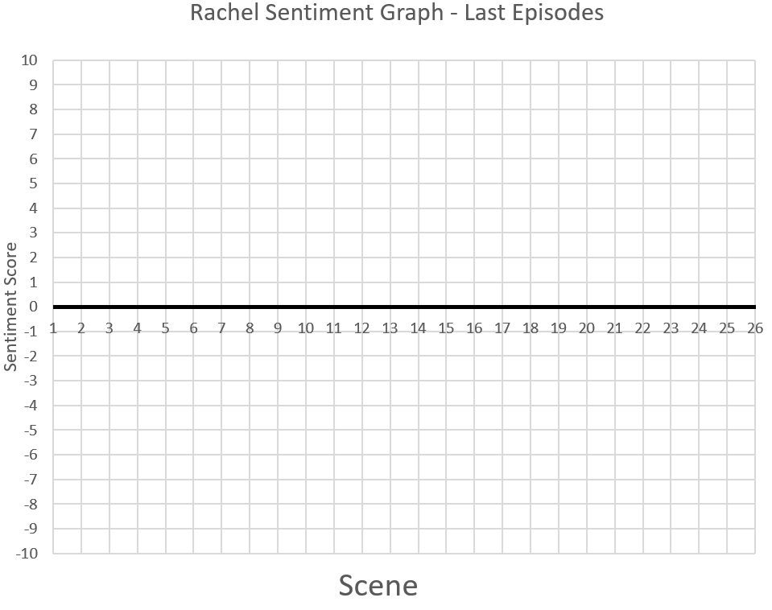Question 16) Please plot your feelings towards **Rachel** throughout the final two episodes.



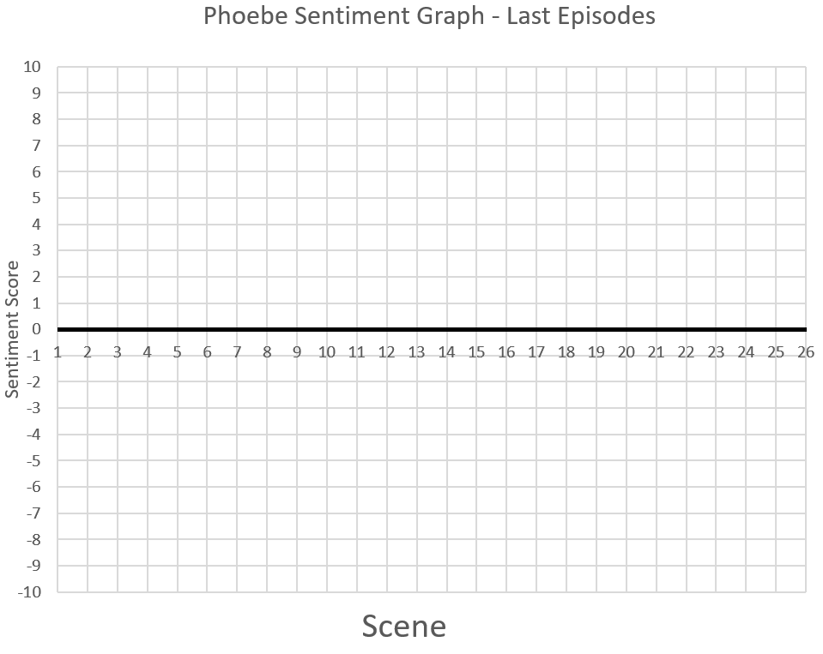Question 17) Please plot your feelings towards **Phoebe** throughout the final two episodes.



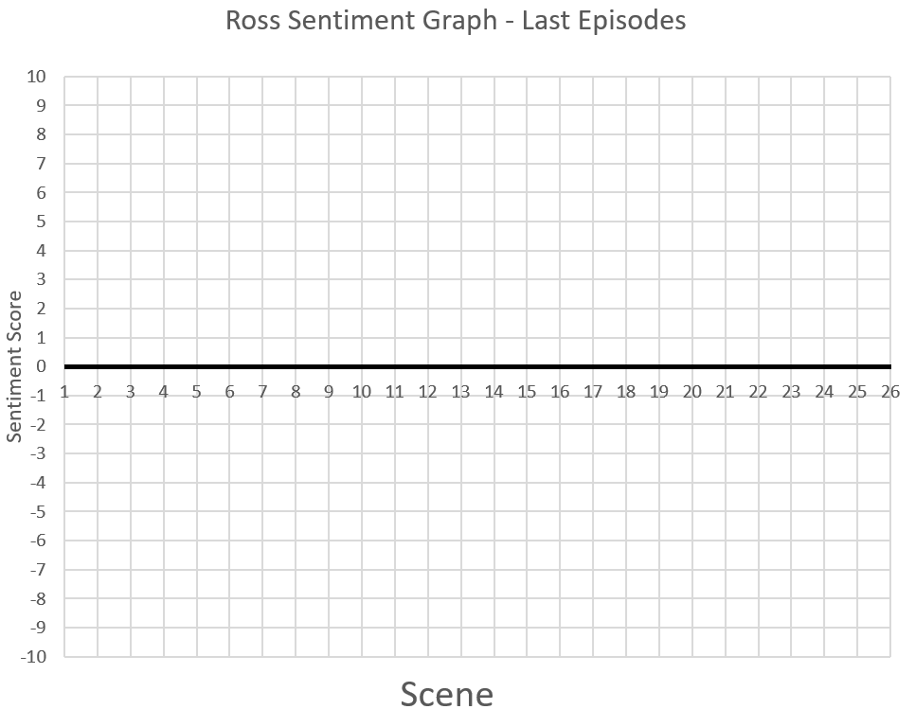Question 18) Please plot your feelings towards **Ross** throughout the final two episodes.

